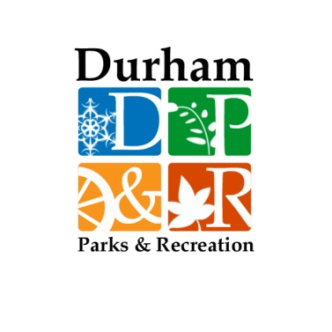

**DURHAM PARKS & RECREATION**

**2 DOVER ROAD**

**DURHAM, NH 03824-2898**

**(P) 603.817.4074**

**(F) 606.868.5572**

Want to be more involved in your community? Durham Parks & Recreation Department (DPR) is seeking Special Events Volunteers for community events. As a Special Events Volunteer, you would have the opportunity to assist with any event that you’re interested in (see list below)! Responsibilities may include helping at the event (2-4 hour commitment) and/or serving on the planning committee for the event (one or two meetings before the event date and a few assigned tasks to help make the event run smoothly).

Becoming a Special Events Volunteer is a great way to get involved in your community. Whether you’re a member of an existing group in need of community service, or you just want to give back locally, this is the opportunity for you! DPR is centrally located; just a short walk from downtown. Most of our events take place within 2 miles of campus.

Contact DPR Director Stefanie Frazee: [sfrazee@ci.durham.nh.us](mailto:sfrazee@ci.durham.nh.us) OR (603)817-4074.

**Durham Parks & Recreation Department Special Events**

Memorial Day Parade (May)

Summer Concerts at Wagon Hill Farm (June, July and August)

Durham Day at Wagon Hill Farm (September)

“Spooktacular” Day in Durham at Jackson’s Landing (October)

Feather Fest at Wagon Hill (November)

Tree Lighting Celebration on Main Street (December)

Spring Festival/Egg Hunt at Town Landing (Late March or Early April)

****In addition to special events, we always have small projects and fun, creative ways to get involved. Looking forward to hearing from you soon!****