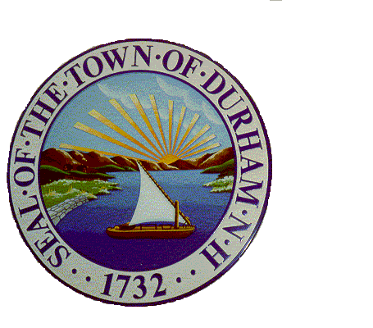

Durham Public Works

100 Stone Quarry Drive
Durham, N.H. 03824
603-868-5578
Fax 603-868-8063

REQUEST FOR BID PROPOSALS
2023-04

PURCHASE OF A 2023 AERIAL BUCKET TRUCK

PROPOSALS DUE Tuesday, May 23rd, 2023 @ 11:00am
(PLEASE COMPLETE AND RETURN ENTIRE DOCUMENT)

COMPILED BY:
Samuel Hewitt
Assistant Director of Public Works
April 21, 2023

